ELEG 309 - Example Problems Chapter 4-2

**Example 4.4**

Determine the current *ID* and the diode voltage *VD* for the circuit in Fig 4.10 with *VDD* = 5 V and R = 1 k. Assume that the diode has a current of 1 mA at a voltage of 0.7 V.

**Exercise 4.11**

Design the circuit in Fig. E4.11 to provide an output voltage of 2.4 V. Assume that the diodes available have 0.7-V drop at 1 mA.

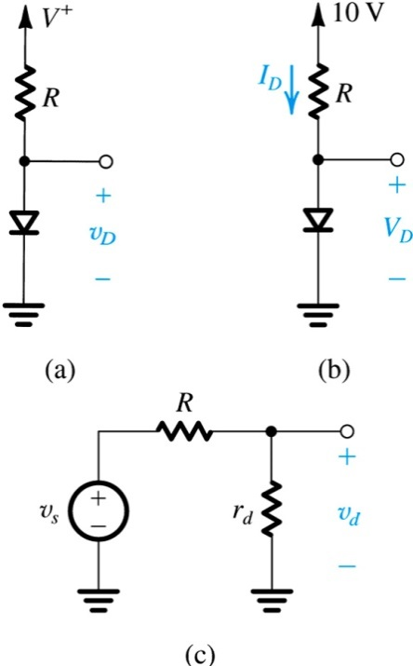**Example 4.5**

Consider the circuit shown in Fig. 4.14(a) for the case in which *R* = 10 k. The power supply *V* has a dc value of 10 V on which is superimposed a 60-Hz sinusoid of 1-V peak amplitude. (This "signal" component of the power-supply voltage is an imperfection in the power-supply design. It is known as the power-supply ripple. More on this later.) Calculate both the dc voltage of the diode and the amplitude of the sine-wave signal appearing across it. Assume the diode to have a 0.7-V drop at 1-mA current.

**Example 4.6**

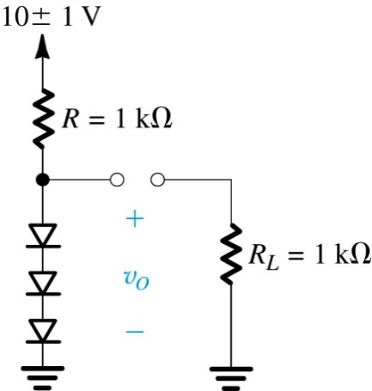Consider the circuit shown in Fig 4.15. A string of three diodes is used to provide a constant voltage of about 2.1 V. We want to calculate the percentage change in this regulated voltage caused by (a) a ± 10% change in the power-supply voltage and (b) connection of a 1-k load resistance.

**Exercise 4.15**

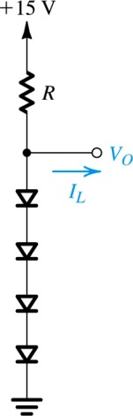Design the circuit of Fig. E4.15 so that *VO* = 3 V when *IL* = 0, and *VO* changes by 20 mV per 1 mA of load current. (a) Use the small-signal model of the diode to find the value of *R.* (b) Specify the value of *IS* of each of the diodes. (c) For this design, use the diode exponential model to determine the actual change in *VO* when a current *IL* = 1 mA is drawn from the regulator.